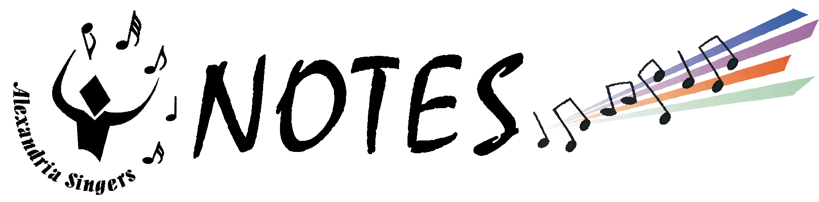

June 2000

All ticket sale money and unsold tickets should be returned to Julie Kraus on Sunday, June 18.
Tickets ordered after June 18 will be held at Will Call and must be paid for at the door.
President’s Corner

June has arrived. We’ll be raising the curtain on another show very soon.
Are you ready? We’ve spent a lot of time learning our music, rehearsing, performing and raising money getting ready for the June show.
But we’re not done yet!! We need to put the polish on the show and we need to SELL TICKETS. Remember that our projected income from the June show is $22,450 from ticket sales, ad sales, and the June raffle. We have less than 3 weeks to generate this revenue. We all need to do our part to sell tickets to our friends, family, neighbors, co-workers (and anyone else you can think of). And, we all pledged to sell a certain number of tickets last fall.
Remember what it was like at Christmas when the curtain opened to a full auditorium at Bishop Ireton?
Wouldn’t it be great if we could do the same at T.C. Williams? We have a GREAT show — now we need an audience to enjoy it. SELL THOSE TICKETS.
Speaking of our audience, we definitely need some assistance in making sure they’re taken care of while we’re backstage. Therefore, we really need your family and friends to help out with door sales, will call or other tasks in the front lobby during our shows.
Please tell Brad Yost or Eva Malecki if you know someone willing to lend a hand. Remember, we make an impression on our audience the moment they walk into T.C. Williams. If they’re standing in line for tickets for 15 minutes or more, they’re not going to be a happy audience. And we definitely want a happy audience!
Keep up the good work. Remember to pace yourselves the next few weeks. Break a leg!!

Sandy

UNIFORM STANDARDS

WOMEN
Uniform: Black pants, white blouse, blue vest, and rosette
Socks: Black trouser socks, not panty hose
Shoes: Black flats, NO sneakers

Accessories: Barrettes, hair bands must be simple & blend with hair color. No hair bows, ribbons, scarves, flowers, etc.

Jewelry: Earrings should be formal; Silver, rhinestone or pearl -- Moderate in size, should not dangle; one per ear. No watches, bracelets or necklaces. Wedding rings ok

MEN
Uniform: Black pants, white shirt, (don’t wear a t-shirt underneath) blue vest, and blue tie

Socks & Shoes: Black socks; Black dress shoes, NOT patent leather. NO sneakers

Accessories: No watches, bracelets or necklaces. Wedding rings ok

NOTE THESE DATES AND TIMES

Tuesday, June 13
Performance for Lincolnia Residents
Report time: 6:45 p.m.
Wear your casual uniform
Concert: 7 p.m.

We’ll be singing:
And All That Jazz
Razz-a-ma-Jazz
I’m Just a Lucky So and So
Jennifer’s Rabbit
Grease
Ragtime
St. Louis Blues
Swing Dancin’

Thursday, June 15
Performance: Ft. Ward Park
Report: 7:30 p.m.
Wear your casual uniform

We’ll be singing:
All You Need Is Love
‘Deed I Do
Get Happy
I’m Just a Lucky So and So
I’ve Got the World on a String
Lullaby of Broadway
Ragtime
St. Louis Blues
+ more TBA

Saturday, June 17
Rehearsal: 9 a.m. - 1 p.m.
Location: John Calvin Presbyterian Church,
Annandale

Costume Change “Cheat Sheet”
And All That Jazz ++
Razz-a-ma-Jazz ++
I’m Just a Lucky So and So
Laura

Mr. Cellophane

Hunchback of Notre Dame ++

Twilight Tone
Jennifer’s Rabbit

Orange-Colored Sky

Grease Medley ++

INTERMISSION

Ragtime ++

Ain’t Misbehavin’

All You Need is Love
With A Little Help From My Friends

MC’s Number -- Anything Goes

Swing Dancin’ ++
‘Deed I Do
St. Louis Blues

Nancy - Gershwin Preludes

And All That Jazz 2 ++

Chorus Costume: Black turtlenecks/pants

Curtain closes. Singers exit stage; change into white shirts/blouses; turn in collars, blousen sleeves; add peasant collars and skirts. Put tie/rosette in pants pocket. Place scarves in waistband behind backs.

Curtain closes. Remove peasant collar/skirts & place in baskets. Take blue vests from hangers, add ties/rosettes.

Curtain closes. Put vests back on hangers.
Put on colorful shirts/letter sweaters.

Change into costumes: WASP, Immigrant, or Jazzie

Curtain closes. All change into black turtlenecks/pants

Curtain closes. Add gold lapels and button colorful shirts over them

Blackout. Remove colorful shirts to reveal gold lapels over turtleneck

PERFORMANCE ETIQUETTE

IT’S SHOW TIME!!!
Everyone must be in their uniforms, in full make-up
and ready to go on stage by the Report Time
or you will not be allowed to perform.
(This includes Dress Rehearsal.)

Risers: Standing on risers takes some getting used to. The key is to be flexible — adjustments will be made along the way — so be prepared to be moved during show week.

Window: It is important that you see the director and you are seen when you are performing.
Therefore, be very conscious of your “window” — the space between the two people in front of you. When you are performing, check periodically to be sure you’re the same distance from those on either side of you.
In addition, you should still be aware (when doing choreography) how wide or high your arms can go so that you’re not blocking others or threatening to propel them off the riser.

Appearance: Singers are expected to adhere to the uniform standards.
Also, remember personal hygiene is very important. Be sure to wash your uniform and other costume items after every show. Shower, use deodorant, avoid spicy foods, brush your teeth and use mouthwash. Do NOT wear perfume, after shave, cologne, etc., and avoid using scented hair sprays and other products before going on stage. These perfumed products can be a source of irritation to those around you. In addition, everyone (men & women) must wear stage make-up. The lights are bright and wash out our faces if we don’t wear it. Be sure to ask for assistance if you don’t know how to apply it.

Attitude: SMILE!!!! HAVE FUN!!!
Having the right attitude on stage is as important as knowing your music and your moves.
The audience will enjoy the show more if they see you are enjoying the show. So, put on your “Show Face.” This means during rehearsals too. If you practice with a smile, it’ll just happen naturally. But, avoid primping, scratching, adjusting your glasses, etc., on stage because that will make you stick out from the rest of the chorus and draw unwanted attention to you from audience members.

BREAK A LEG!

