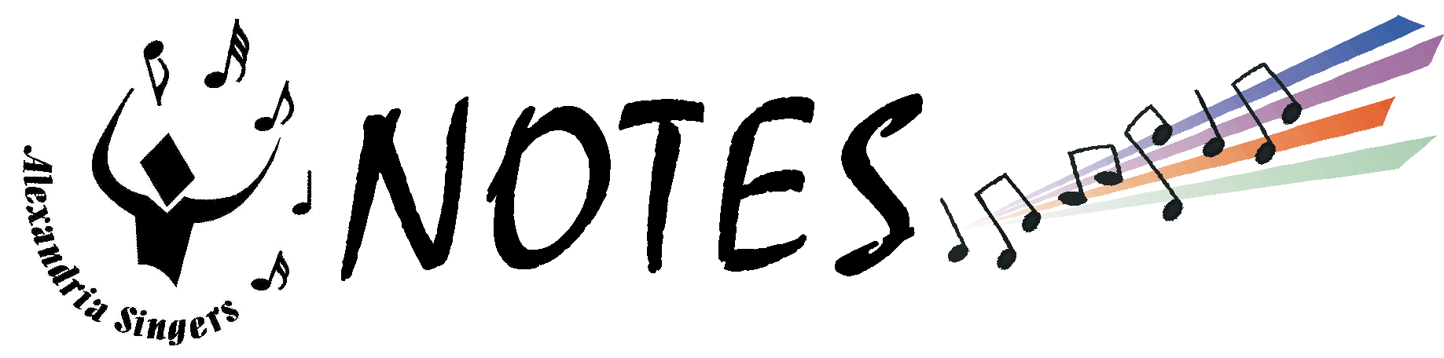
April 2000
President’s Corner

Wow!! Show time’s coming.
Are you ready? I’m getting r-e-a-l excited. As much as I enjoyed performing with Da Vinci’s Notebook last year, I really missed our June show. If you haven’t been part of one yet, you’ll know what I mean soon enough.
Please hold onto this newsletter — it has LOTS of details about the show and is a handy reference.
In addition to the show, we have another event to take care of. June 3rd is the car wash/yard sale. Keep looking around the house, garage, attic, etc., for items you no longer want. Those of you who have buckets, garden hoses, nozzles, etc., we can use for the car wash, please tell Marla Howell.

ELECTION RESULTS
Congratulations to the newly elected officers for the 2000-2001 season.
President Sandy Carson
First VP Kimberly Miles
Administrative VPs
Marla Howell & Linda Herbert
Performance VP Jill Thompson
Communications VP Diane Wessing
Marketing VP Paula Heichel
Membership VP Marissa Dolcich
Secretary Dennis Eckhout
Treasurer Debbie Johnson

Thanks to ALL who ran for office. Your willingness to serve the Singers is greatly appreciated.

Sandy

Meet Our MC

Due to the fact our last MC, Taunya Martin, got married and moved to Belgium last year, it became necessary to find a new MC for our June Show.
After a thorough audition, Dick Reed was hired to host our annual song and dance spectacular.
Dick has been very active in community theater as both an actor and director. He has starred as Frank Butler in Annie Get Your Gun, King Arthur in Camelot, and Sky Masterson in Guys and Dolls, just to name a few of his roles in the more than 25 shows in which he’s been involved.
He’ll be coming by a rehearsal or two to get to know the Singers. Please make him feel welcome.

JUNE SHOW ORDER

ACT I
And All That Jazz 
Razz-a-ma-Jazz 
I’m Just a Lucky So-and-So
Laura
Mr. Cellophane
Hunchback of Notre Dame 
Twilight Tone
Jennifer’s Rabbit
Orange-Colored Sky
Grease Medley  

ACT II
Ragtime 
Ain’t Misbehavin’
All You Need is Love
With a Little Help From My Friends
MC’s Solo
Swing Dancin’ 
‘Deed I Do
St. Louis Blues
Nancy’s Number
And All That Jazz (Reprise) 

Uniform & Costume Info

All Singers will need the following costume items for the June Show. If you need help finding an item, or have questions, please see Lorie Levine or Eva Malecki.

Casual Uniform: Black pants, white blouse/shirt, blue vest, tie or rosette, black socks and shoes. Please see “Uniform Standards” (below) regarding jewelry, etc.

Black turtleneck: Consider this part of your uniform. It must be long-sleeved, but can be a mock or regular turtleneck. Please be sure it’s BLACK, and it’s not faded.

Hunchback: Ladies: peasant collars and skirts (Singers will provide)
Men: peasant collars (Singers will provide)
All: Bright, solid-colored scarf

Grease: All: Long-sleeved, colorful shirts or letter sweaters/jackets

Swing Dancin’: All: Long-sleeved, colorful shirts (with collar) -- no pastels, prints, neutrals, etc.

Ragtime
WASPs — All in white/off-white/ecru
Women: White blouses, white pants or skirts/dresses; white socks/shoes.
Parasols, big hats (Singers provide)
Men: white shirts, khakis, tweed or linen blazers with white vests, white socks/shoes, straw hats

Immigrants — Earth tones/brown/grey
Women: White Casual Uniform blouses or black turtlenecks; shawls, black socks/shoes.
Full skirts in browns or greys, (pilgrim 1/2 skirts w/ aprons -- Singers provide)
Men: black turtlenecks or work shirts in browns, greys, black pants, black socks/shoes

Jazzies — All in Black - Women & Men: Black turtleneck and black pants, socks/shoes.
Men: derby w/ colorful hatband, suspenders, and bow tie (Singers provide)
Ladies: colorful vests (Singers provide)

UNIFORM STANDARDS

WOMEN
Uniform: Black pants, white blouse, blue vest, and rosette
Socks: Black trouser socks, not panty hose
Shoes: Black flats, NO sneakers

Accessories: Barrettes, hair bands must be simple and blend with hair color
No hair bows, ribbons, scarves, flowers, etc.

Jewelry: Earrings should be formal; Silver, rhinestone or pearl -- no colors;
Moderate in size, should not dangle; one per ear -- Maximum
No watches, bracelets or necklaces, wedding rings ok

MEN
Uniform: Black pants, white shirt, (don’t wear a t-shirt underneath) blue vest, and blue tie
Socks & Shoes: Black socks; Black dress shoes, NOT patent leather, NO sneakers
Accessories: No watches, bracelets or necklaces, wedding rings ok

Mark Your Calendars!

Mark Your Calendars!
JUNE

Saturday, June 3
Singers Car Wash/Yard Sale FUNDRAISER
Fairlington Methodist Church, King Street, Alexandria
Set up: 7 a.m.

Friday, June 9
Choreography Rehearsal
7:30 - 10 p.m. @ Durant Center
Everyone should attend!

Tuesday, June 13
Performance for Lincolnia Residents
Report time: 6:45 p.m. - Wear your casual uniform
Concert: 7 p.m.

Thursday, June 15
Performance: Ft. Ward Park
Report: 7:30 p.m.
Wear your casual uniform

Saturday, June 17
Rehearsal: 9 a.m. - 1 p.m. Location: TBA

Show Week — Rehearsals
at T.C. Williams High School

Sunday, June 18: Report time - 5 p.m.
Monday, June 19: Report time - 7 p.m.
Tuesday, June 20: Report time - 7 p.m.
Wednesday, June 21: Report time - 7 p.m.
(or 9 p.m. if it rains)
Thursday, June 22: Report time - 9 p.m.

SHOW TIMES!
Friday, June 23 at 8 p.m.
Saturday, June 24 at 8 p.m.
Sunday, June 25 at 3 p.m.

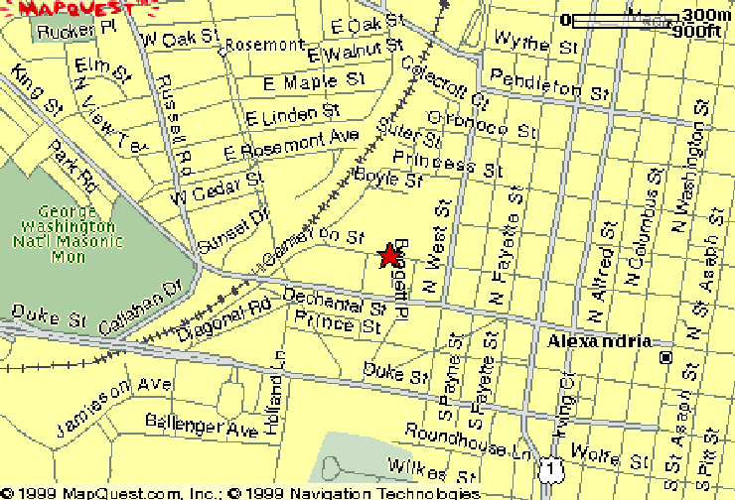
All Chorus Dance Rehearsal

WHEN: Friday, May 12, 2000
7:30 - 10 p.m.

WHERE: Durant Recreational Center
1605 Cameron Street, Alexandria

Everyone should make every effort to attend. We will be using risers in front of mirrors so we can see ourselves as we practice our choreographed moves.

